Chihuahua Desert
From https://www.nps.gov/im/chdn/ecoregion.htm

Location
The Chihuahuan Desert Ecoregion covers nearly 647,500 square kilometers (250,000 square miles), with over 90% of its area within the nation of Mexico. It is the largest desert in North America, extending nearly 1,500 km from south of Albuquerque, New Mexico to 250 km north of Mexico City. Parts of the Mexican states of the Chihuahua, Coahuila, Durango, Zacatecas, Nuevo León, and San Luis Potosí, as well as the southeastern corner of Arizona and large parts of New Mexico and the Trans-Pecos region of Texas lie within the Chihuahuan Desert Ecoregion.
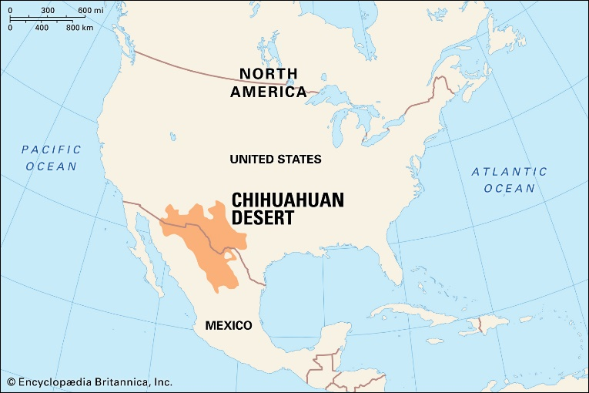
Climate and Topography
The Chihuahuan desert differs from the Sonoran and Mojave deserts because it receives more summer rain during monsoon thunderstorms and has colder winters. The climate includes hot summers and cool to cold, dry winters. Annual precipitation ranges from 150 to 500 mm (approximately 6 to 20 inches), with a large part of the rain falling in the form of monsoonal rains during the summer months. The basin and range topography of the Chihuahuan Desert consists of broad desert valleys (basins) bordered by terraces, mesas, and mountains (ranges). Salt lakes or playas can form because rainwater drains internally in these closed basins. Dune fields composed of quartz or gypsum sand are also common.
Flora and Fauna
The eastern boundary of the Chihuahuan Desert is one of the oldest and richest centers of plant evolution on the North American continent. A wide variety of vegetation communities are present in the in the ecoregion, ranging from desert shrublands at lower elevations and conifer woodlands at the highest elevations. The Chihuahuan Desert boasts as many as 3,500 plant species, including nearly a quarter of the world’s cactus species. Approximately 1,000 of the plant species grow only in this ecoregion. Some distinctive habitat types in the Chihuahuan Desert include yucca woodlands, playas, gypsum dunes, and a diverse array of freshwater habitats. Vast desert grasslands and a wide variety of yuccas and agaves, including many endemic species, also make this desert extremely unique.

