HOW ELEVATION, LATITUDE, WIND SYSTEMS, OCEAN CURRENTS, POSITION ON A CONTINENT, AND MOUNTAIN BARRIERS INFLUENCE TEMPERATURE, PRECIPITATION, AND DISTRIBUTION OF CLIMATE REGIONS

Elevation
Locations in higher elevations experience cooler temperatures and high amounts of precipitation in the form of snow. Thin air in higher elevations lacks ability to hold heat causing both cooler temperatures and precipitation.

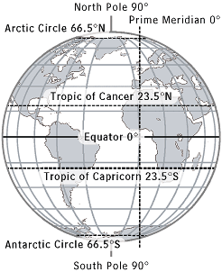
Latitude
Latitude has a significant impact on temperature with locations nearest the equator experiencing high temperatures and those near the poles experiencing cold temperatures. Average yearly temperatures decrease in progression from north and south of the equator. Latitude has a slight influence on precipitation, mostly near the equator where rising hot air contributes to the humidity.

Wind systems
Wind systems serve to move warm or cool air across the earth’s surface and to distribute precipitation around the globe. Wind systems can bring moist air from across an ocean or dry air from across land. Monsoons are an example of a wind pattern that brings moist air across areas of South Asia causing heavy rainfall. Temperatures in coastal locations are affected by the temperature of the water nearby and the winds that cross over the water.
Ocean currents
Ocean currents help to distribute heat away from the equator. Warm water at the equator circulates toward the tropics. Water from the tropics circulates to the poles where the water cools and then circulates back towards the equator. Wind systems have an effect on ocean currents and like wind systems, ocean currents also transfer precipitation around the world.

Position on continent
Locations that are located nearer coastlines tend to experience more moderate temperatures as opposed to locations that are further inland. Locations that are further inland generally experience greater daily and seasonal temperature variations. Locations near coastlines also tend to experience greater amounts of precipitation. Position on continent is most evident in the middle latitudes and it along with latitude has the greatest effect on climate.

Mountain Barriers
Mountain barriers have a great effect on precipitation. As air rises to pass over a mountain barrier it releases moisture as the air cools. This creates a wet side or windward side and a dry side or leeward side to mountain barriers. The windward side of a mountain is generally on the side closest to ocean. This process is referred to as orographic precipitation or the rain shadow effect. Windward sides of mountain ranges receive higher average precipitation and leeward sides of mountain ranges tend to receive lower average precipitation.
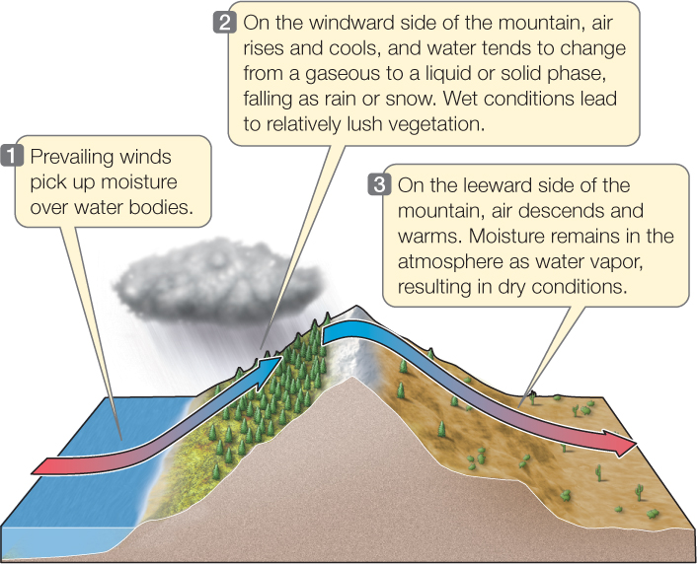

Distribution of Climate Regions
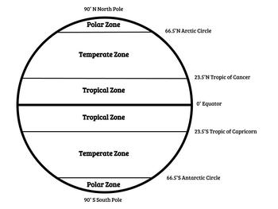
Climate regions are characterized by a combination of average temperatures with average amounts of precipitation. There are five major categories of climate; polar, temperate, tropical, arid, and highland along with many sub categories within these larger groups.
The polar climate region is located in the higher latitudes and is characterized by generally low temperatures, low precipitation, long winters and short summers. Within the polar climate region are the sub regions of subarctic, tundra, and ice cap.
The temperate climate region is located in the mid latitudes and is characterized by seasonal temperature variations and seasonal precipitations variations. Within the temperate climate region are the sub regions of marine west coast, Mediterranean, humid subtropical and humid continental. Humid subtropical climates vary around the globe.
The tropical climate region is located in the low latitudes and characterized by warm temperatures year-round and abundant rainfall. Within the tropical climate region are the sub regions of tropical rainforest and savanna.
The arid/dry climate region is characterized by variations in temperatures and low rainfall. This climate zone is most commonly sub divided into desert or steppe.
Highland climate regions are located in higher elevations no matter the latitude.

