Physical Patterns and Processes
Unit Vocabulary
geography – study of the Earth’s people, places, features, and environment from a spatial perspective
patterns – an observable model, style or trend, generally observed on maps in geography
processes – a particular method that brings changes to the physical or human geography
human geography – study of human activities related to interaction with the environment and control of the Earth’s surface
physical geography – study of the patterns and process related to the Earth’s surface
geographic factors – physical and human conditions that impact the environments of places and regions
landforms – a specific physical feature of the Earth’s surface
biomes – large ecosystems characterized by common climate, common vegetation, and common animal life
lithosphere – the solid surface of Earth, including the soil and landforms
hydrosphere – the water areas of Earth, including oceans, lakes, rivers, ground water, glaciers and water vapor
biosphere – the areas of Earth that support plant and animal life
atmosphere – the gaseous area of air surrounding Earth
tectonic forces – physical process involving the movement of the Earth’s crust
erosion – the wearing away of the Earth’s surface caused by the movement of water, ice, or wind
soil building process – the creation of organic matter formed from weathered rock, air, and water
climate –a pattern of the combination of precipitation and temperature over time

HOW CHANGES IN SOCIETIES HAVE LED TO DIVERSE USES OF PHYSICAL FEATURES
- Increased demand for agricultural production, (2) new technologies introduced to produce energy, and (3) policies to deal with flooding are just a few examples of societal changes that have resulted in diverse uses of physical features over time.
Population increases along with the spread of industrialization has also resulted in various diverse uses of physical features. Examples include, (1) terrace farming, (2) building of dikes, levees, dams, and polders.
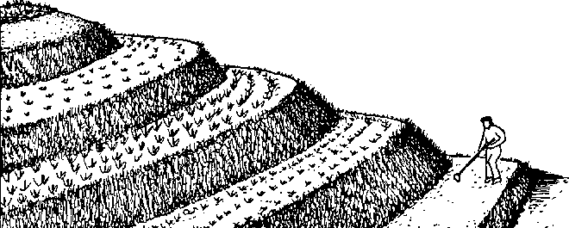
Terrace farming

