PHYSICAL PROCESSES AFFECT THE LITHOSPHERE, ATMOSPHERE,
HYDROSPHERE, AND BIOSPHERE
Hurricanes – causes high winds and large amounts of rainfall affecting the atmosphere, hydrosphere and lithosphere; can uproot plants, stones, or other loose materials affecting the lithosphere; can cause loss of plant, animal and human life affecting the biosphere
El Nino – impacts precipitation levels causing periods of drought and flooding affecting all spheres
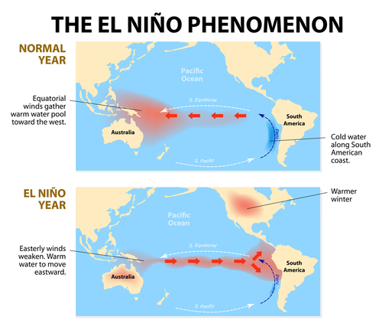
Earthquakes – causes fractures in the lithosphere; possible damage to lives in the biosphere; tsunamis are created in the hydrosphere and threaten the lithosphere
Volcanoes – releases gases and ash into the atmosphere; released ash affects lithosphere and hydrosphere; lava flows affect the lithosphere; eruptions can create craters in the lithosphere
Lithosphere – the outermost shell of the earth (the land, the earth)
Atmosphere – the layer of air that surrounds the earth
Hydrosphere – comprised of all the water that is on earth including lakes, rivers, oceans and underground supplies
Biosphere – refers to the living plants and animals that inhabit the land and water on the earth, also known as ecosystems

