PHYSICAL PROCESSES THAT AFFECT THE
ENVIRONMENTS OF REGIONS
Weather refers to the day to day condition of the atmosphere and is affected by solar energy, pressure systems and cloud cover.
Weather is different than climate. Weather is the conditions today, while climate is the typical conditions based on decades of records. So, the climate of El Paso is generally dry with mild winters and hot summers, but today’s weather was 90 degrees with no chance of rain.
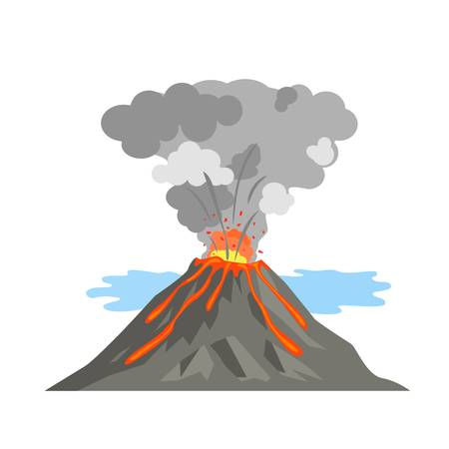
Tectonic forces are the plates that make up the earth’s crust. Plate movements cause earthquakes and volcanic activity, as well as affecting the physical features of the earth. Divergent plate boundaries refer to areas where tectonic plates have moved apart. Convergent boundaries refer to areas where one tectonic plate is forced under another tectonic plate. Transform boundaries refer to areas where tectonic plates slide past each other. Tectonic plate movement results in earthquakes, volcanic activity and the formation of mountains and rift valleys. (see the diagram of plate boundaries)
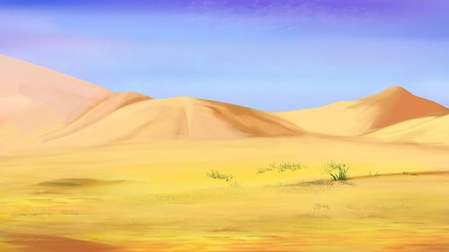
Erosion is the movement of weathered material by wind, water or ice. Water erosion is evident in rivers and along coastlines. Wind erosion is responsible for the movement of particles from one location to another, creating such physical features as sand dunes. Ice erosion occurs when large ice structures, generally glaciers, transport and deposit materials.
Erosion is the movement of earth by (1) wind (2) water and (3) ice. Erosion can change the shape of place by creating canyons and giant sand dunes.
Soil-building is the physical creation of soil from rocks (sand), organic matter (dead stuff), air and water. Erosion is generally a part of the soil-building process.

