Case Study: The Polders of the Netherlands
Much of the Netherlands Is Below Sea Level
Today, around 27% of the Netherlands is actually below sea level. This area is home to over 60% of the country's population of approximately 17 million people. The Netherlands, which is roughly the size of the U.S. states Connecticut and Massachusetts combined, has an average elevation of 36 feet (11 meters).
A huge part of the Netherlands is highly susceptible to flooding.
From https://www.thoughtco.com/polders-and-dikes-of-the-netherlands-1435535

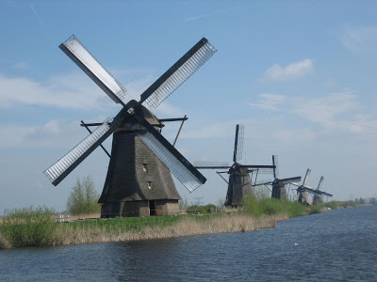
Polder, tract of lowland reclaimed from a body of water, often the sea, by the construction of dikes roughly parallel to the shoreline, followed by drainage of the area between the dikes and the natural coastline. Where the land surface is above low-tide level, the water may be drained off through tide gates, which discharge water into the sea at low tide and automatically close to prevent re-entry of seawater at high tide. Windmills are used to pump salt water back to the sea to create a polder
To reclaim lands that are below low-tide level, the water must be pumped over the dikes. If a sediment-laden stream can be diverted into the polder area, the sediment may serve to build up the polder bottom to a higher level, thus facilitating drainage.
Soil in areas newly reclaimed from the sea contains so much salt that most plants will not grow. Procedures for ridding the soil of salt, therefore, must be used along with diking and draining to develop agriculturally productive land.
The most notable example of polder construction is the system developed adjacent to the IJsselmeer (Zuiderzee) in the Netherlands.
From https://www.britannica.com/science/polder
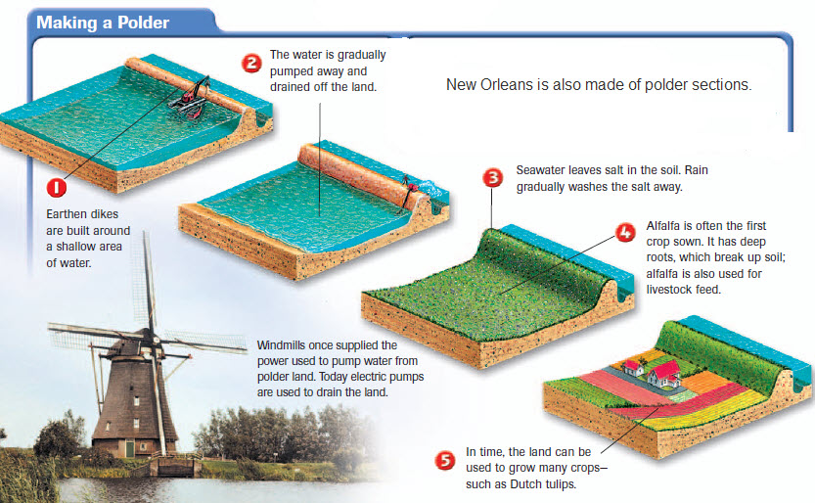
This graphic illustrates how a polder is constructed by first building an earthen sea wall (dike). Then, using pumps, the salt water is slowly removed from the reclaimed land.

The Future
Scientific predictions for global warming have the Dutch nervous about the future of their country. Globally, sea levels may rise up to a foot (0.3 m) during the early part of this century and up to nearly three feet (0.9 m) by century’s end. Sea level rise will also bring higher storm surges from the more intense coastal storms that scientists also predict may accompany global warming. These extreme events can over-top existing dikes, flooding polders with salt water, creating conditions similar to the flooding in New Orleans from Hurricane Katrina. Intense rainfall events expected inland also will create the risk of more frequent and severe river floods that may inundate polders.
From https://blog.nationalgeographic.org/2014/05/05/geography-in-the-news-polder-salvation/

