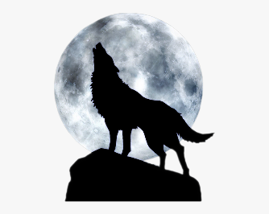
What is a lunar year?
A lunar year or lunar calendar is one that is based on the cycles of the moon phases. The problem with a lunar calendar is that it drifts away from the seasons. Each year, the start and end dates of each month drift by 11 days. In order to stay correct, every lunar calendar has to deal with this drift away from the calendar year.
A lunar month lasts 29.53 days. So, after 12 lunar months, you’re about 354 days. This is short of the 365 days that it takes the Earth to orbit the Sun. This is a problem since after about 3 years, the lunar months are out of cycle with the solar year by about a month. And this problem would just continue.
To make the lunar calendar work in China, farmers would add in a leap month every 3 years. This would mostly get the lunar month to line up with the solar year, but they still drifted apart somewhat. For some calendars used for religious purposes, such as the Islamic Hirji calendar, they never bothered to sync up the calendars and let them drift. It takes 33 years for the cycle of lunar years to get back to the original position.
From https://www.universetoday.com/20620/lunar-year/
The Definition of a Lunar and Solar Year
12 lunar months make up a lunar year. A lunar month can also be defined as the time the moon takes to pass through each of its phases (new moon, half moon and full moon) and return back to its original position. A lunar month takes 29.5 days, although this varies slightly around this average.
We call the time period required for Earth to complete one revolution around the sun a solar year. A solar month means one twelfth of a solar year. Calendar months differ from this, but in practice the differences are minor and exist so we can have a whole number of days in each month.

Lunar and Solar Calendar Conventions
Most places around the world use a solar calendar rather than a lunar one. However, Muslims and Jews follow a lunar calendar. Islamic calendars, otherwise known as Hijri calendars, are based on the lunar cycle, and its year consists of 12 lunar months. The Hijri calendar plays an important role for religious purposes and the Muslim religious festivals are based on this calendar. A Jewish calendar uses primarily lunar definitions, and each month begins on the new moon, but the years are based on solar years. Chinese calendars are a type of lunisolar calendar, a combination of a lunar calendar and a solar calendar.
From https://sciencing.com/difference-between-solar-lunar-years-8513472.html

